OZONE Store

Quick Start Guide
November 17, 2015

Publication/Revision History
Release | Date
Revised – OZONE Store 7.17.0 FOSS | November 17, 2015
Revised – OZONE Store 7.16.1 FOSS | September 3, 2014
Revised – OZONE Store 7.16.0 FOSS | August 22, 2014
Revised – OZONE Store 7.14.2 GOSS | May 27, 2014
Revised – OZONE Store 7.15.1 | April 29, 2014
Revised – OZONE Store 7.15.0 | April 15, 2014
Revised – OZONE Store 7.14.0 | April 1, 2014
Revised – OZONE Store 7.13.0 | March 18, 2014
Revised – OZONE Store 7.12.0 | March 4, 2014
Revised – OZONE Store 7.11.0 | February 19, 2014
Revised – OZONE Store 7.10.0 | February 4, 2014
Revised – OZONE Store 7.9.0 | January 21, 2014
Revised – OZONE Store 7.8.0 | January 7, 2014
Revised – OZONE Store 7.7.0 | December 24, 2013
Revised – OZONE Store 7.6.0 | December 10, 2013
Revised – OZONE Store 7.5.0 | November 26, 2013
Revised – OZONE Store 7.4.0 | October 25, 2013
Revised – OZONE Store 7.3 | October 8, 2013
Revised – OZONE Store 7.3 | July 31, 2013
Revised – Marketplace 7.2 | June 11, 2013
Note: This revision history addresses the Marketplace project which served as predecessor to the OZONE Store.

Contents
1 Introduction 1
1.1 Objectives 1
1.2 Document Scope 1
1.3 Obtaining the Application Bundles 1
1.4 Dependencies 1
2 Configure Your Environment 2
2.1 Install Java 2
2.1.1 Configure the JAVA_HOME environment variable 2
2.1.2 Configure the JAVA_OPTS environment variables 2
3 Unpack the Bundle 4
3.1 Consolidate the Bundles 4
4 Start the Web Server 5
4.1 Sign in to OWF 5
4.1.1 Add Store to OWF 5
4.2 Sign in to the Store 6
5 Related Documents 7
Tables
Table 1: Tested Browsers 1
Table 2: Related Documents 7
Figures
Figure 1: JAVA_HOME Variable 2
Figure 2: JAVA_OPTS Variable 3
Figure 3: Store Configuration Wizard 6
Figure 4: Store Button on OZONE Toolbar 6

- Introduction
  - Objectives
This quick start guide defines how to setup and run a minimally configured Store. At this end of this procedure you will have the Store running inside the OZONE Widget Framework (OWF) on your desktop.
  - Document Scope
This guide is intended for administrators or developers who wish to learn how to install and deploy the Store for the purposes of gaining an overall familiarity with product.
  - Obtaining the Application Bundles
Download the following application bundle from:
- https://github.com/ozoneplatform/omp-marketplace/releases
- https://github.com/ozoneplatform/owf-framework/releases
  - Dependencies
The Store requires JRE 1.6 or higher. It supports Internet Explorer 7 and higher and Firefox 17 and higher. The products are tested against the following browsers:
Table 1: Tested Browsers
Browsers | Versions
Internet Explorer | 7 & 9
Firefox | 17
Chrome | 33
- Configure Your Environment
This procedure is written for Windows Vista/7, but can be easily adapted to other versions of Windows or Linux.
  - Install Java
The Store and OWF require Java. At a minimum the Java 6 SE runtime environment must be installed to run the applications. The Oracle JRE will suffice for this quick start. Download the installation package that is appropriate for your system. Take note of where the JRE is installed (for example: C:\Program Files\Java\jre7) - this path will be used in the next section.
    - Configure the JAVA_HOME environment variable
- Click the start button and in the search field, type environment variable
- Select the option that says "Edit environment variables for your account"
- Click "New..."
- Fill in the variable name (JAVA_HOME) and the path obtained in the previous section:
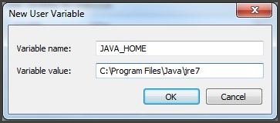
Figure 1: JAVA_HOME Variable
- Click Ok to save the variable
    - Configure the JAVA_OPTS environment variables
- Click "New..."
- Fill in the variable name (JAVA_OPTS)
- Fill in the value with: -Xms512m -Xmx1536m -XX:PermSize=128m -XX:MaxPermSize=256m
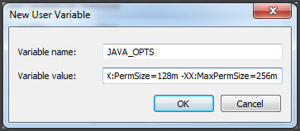
Figure 2: JAVA_OPTS Variable
- Click OK to save the variable
- Click OK to close the Environment Variables window
For the rest of this procedure, you will need:
- Familiarity with navigating the filesystem, creating directories, and copying files.
- Read, create and execute privileges to the suggested filesystem locations.
Note : Notepad++ is a free text editor that meets the above requirement and can be found at the following location: http://notepad-plus-plus.org/

- Unpack the Bundle
If you have not yet obtained the bundles for the following steps, please see section 1.3 : Obtaining the Application Bundle for more details.
- Create a folder on your desktop and name it franchise-store
- Unzip the Franchise Store bundle to: Desktop\franchise-store
- Create a folder on your desktop and name it owf
- Unzip the OWF bundle to: Desktop\owf
  - Consolidate the Bundles
The Store and OWF applications, while meant to work together, can also be run independently - therefore, they are packaged as such to easily run them as standalone products. The following steps will consolidate them into a single web application server that can be run locally on your computer.
- Copy the file franchise-store\apache-tomcat\webapps\marketplace.war to owf\apache-tomcat\webapps
- Copy the following files from franchise-store\apache-tomcat\lib to owf\apache-tomcat\lib
- MarketplaceConfig.groovy
- mp-override-log4j.xml
- MarketplaceConfig.xml (not present by default)
- Copy the following files from franchise-store\apache-tomcat to owf\apache-tomcat
- mktplProdDb.h2
- mktplProdDb.lock
- Start the Web Server
Double-click the file owf\apache-tomcat\start.bat to start the applications. The startup process may take up to a few minutes the first time it is run. You will know it is done when the command prompt output stops scrolling and a line like this is displayed:
2013-05-08 10:43:00,433 [main] INFO org.apache.catalina.startup.Catalina- Server startup in 110769 ms
  - Sign in to OWF
- Open your web browser and navigate to: https://localhost:8443/owf.
- If you receive warnings about untrusted connections, ignore the warnings or add exceptions, using the dialog box.
- Log in to OWF with testAdmin1 and password as the username / password.
    - Add Store to OWF
To add a Store through OWF:
- Open the OWF drop-down User Menu and click Administration.
- This opens the Administration Manager. Click Configuration to open the Configuration Console.
- From the left-hand panel, click Store.
- Click the Add Store button.
- This opens the Store Configuration window. Enter the Store URL, then click Next (Figure 3). Click next and OWF will use the URL and automatically gather Store details.

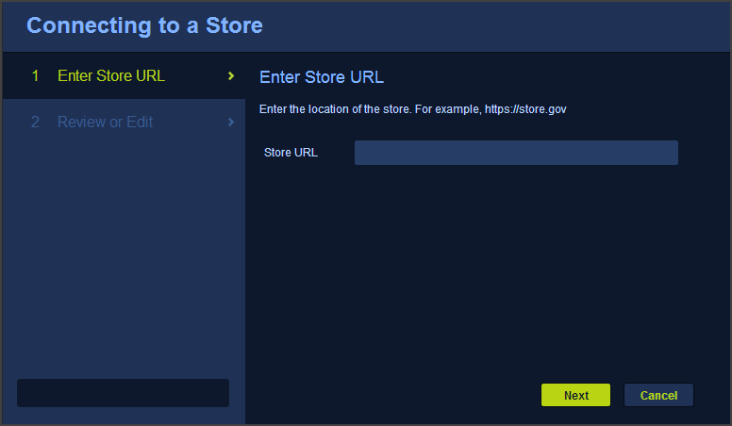
Figure 3: Store Configuration Wizard
- The Review page appears. Review or Edit the Store details:
  - Review the icon used to identify the Store to users in OWF
  - Add a Store Name to identity the Store to users in OWF
  - Click Save.
- Refresh your browser.
The Store button will appear on the OZONE Toolbar for all OZONE users (see below).
Note: If the Store button does not appear in the toolbar, refresh your browser window.
Figure 4: Store Button on OZONE Toolbar
  - Sign in to the Store
- Open your web browser and go to: https://localhost:8443/marketplace
- If you receive a warning in your browser about an untrusted connection, add an exception
- Sign in to the Store using testAdmin1 and password
- Related Documents
Table 2: Related Documents
Document | Purpose
User Guide | Searching, Creating and Editing Listings, Adding Comments, Ratings, Navigating a Store, Scorecards Explanation of Store Elements
Administrator’s Guide | Importing / Exporting Store Data, Adding Affiliated Stores, Approving Listings, Creating Types, States, Categories, and Custom Fields; Scorecard Configuration
Configuration Guide | Modifying Default Settings, Security, Database Settings, Upgrading to a newer Store version
Quick Start Guide | Setting Up and integrating the Store into OWF
Release Notes | Epic Stories and Bug Fixes for the Current Build
Bundle Name / Version marketplace-bundle-7.17.0.zip
MARKETPLACE.WAR marketplace.war
Current Version Store 7.17.0
OWF bundle OWF-bundle-7.17.0.zip

